EXPERIMENT-11
11) Perform a 180-degree rotation clockwise along the y-axis for the given image

- CODE
- import cv2
- from tkinter import Tk, filedialog

- root = Tk()
- root.withdraw()

- file = filedialog.askopenfilename(
- title="Select Image",
- filetypes=[("Image Files", "*.jpg *.jpeg *.png")]
- )

- img = cv2.imread(file)

- if img is None:
- print("Image not found")
- else:
- rotated = cv2.rotate(img, cv2.ROTATE_180)

- cv2.imwrite(r"C:\Users\Admin\Desktop\rotated_180_image.jpg", rotated)

- cv2.imshow("Original Image", img)
- cv2.imshow("180 Degree Rotated Image", rotated)

- print("180-degree rotation completed successfully")
- print("Saved on Desktop as rotated_180_image.jpg")

- cv2.waitKey(0)
- cv2.destroyAllWindows()

b) INPUT
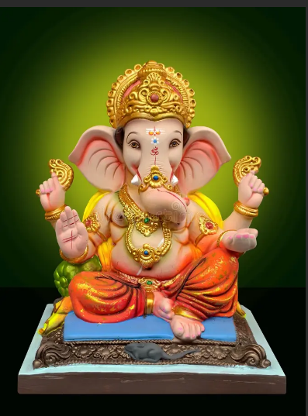
c) OUTPUT
